**DAILY ONLINE ACTIVITIES SUMMARY**

|  |  |  |  |  |  |  |  |  |
| --- | --- | --- | --- | --- | --- | --- | --- | --- |
| **Date:** | **03/08/2020** | | | | | **Name:** | **RIYA CP** | |
| **Sem & Sec** | **IV sem & B section** | | | | | **USN:** | **4AL18CS070** | |
| **Online Test Summary** | | | | | | | | |
| **Subject** | | **-** | | | | | | |
| **Max. Marks** | | **30** | | **Score** | | | **-** | |
| **Certification Course Summary** | | | | | | | | |
| **Course** | **Programming Fundamentals** | | | | | | | |
| **Certificate Provider** | | | **COURSERA** | | **Duration** | | | **13 hours** |
| **Coding Challenges** | | | | | | | | |
| **Problem Statement1:-** | | | | | | | | |
| **Status: -** | | | | | | | | |
| **Uploaded the report in Github** | | | | | **-** | | | |
| **If yes Repository name** | | | | | **-** | | | |
| **Uploaded the report in slack** | | | | | **YES** | | | |

**Online Test Summary: No internals conducted today.**

**Online Certification Course Summary: In today’s session I have completed the course and received the certificate.**

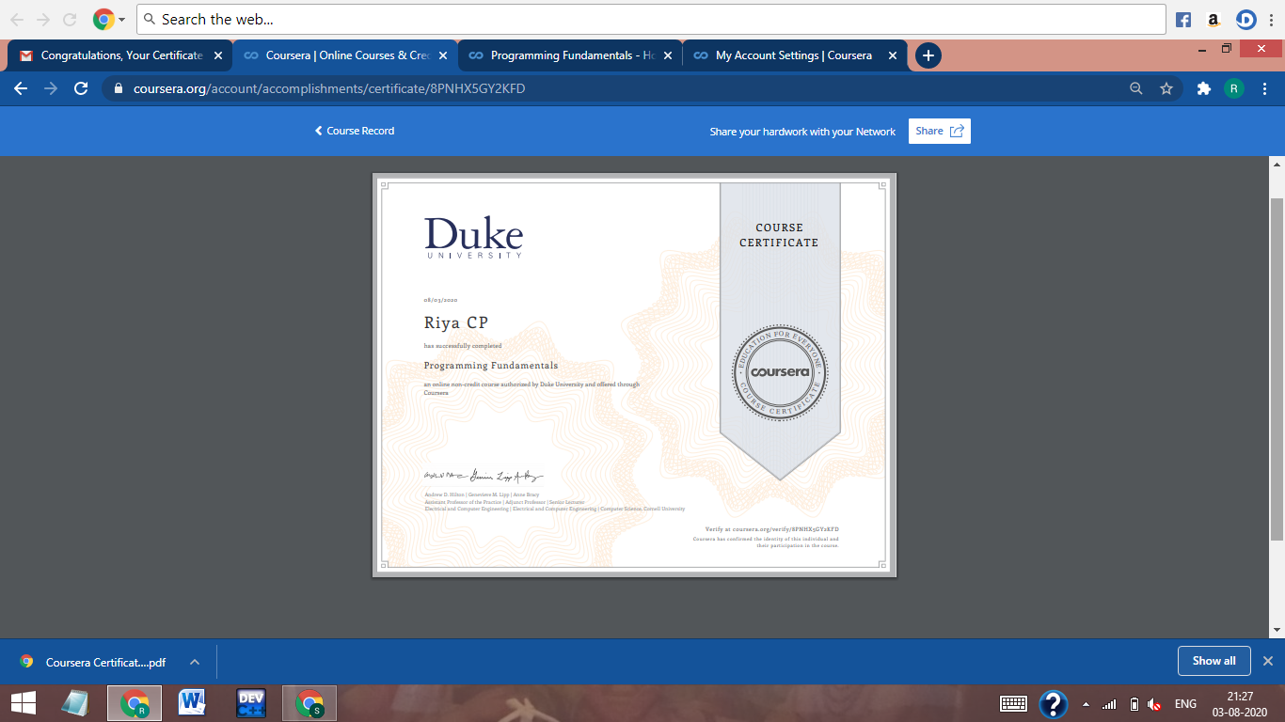

**These are the snapshot of today’s session.**

**Online Coding Summary: No problem statements were given.**

**Workshop:** Today I had attended the Workshop organized by AIET. The Workshop was on ‘ How to develop pythonic coding rather than python coding – Logic Perspective’ done by Dr. S Mohideen Badhusha CSE Dept. There was also Hands-on session through google colab.